# Practice M8: Exam Preparation

For the purpose of this lab and the course, we will consider that we are working in a pure Windows environment either on-premise or in the cloud and using **Hyper-V** as a virtualization solution. All tasks can be achieved under different configuration (another host OS or virtualization solution) with the appropriate adjustments

The expected lab infrastructure consists of six machines. Windows Server 2019 Standard is enough, Desktop experience or core (managed remotely) – it is up to you

## Challenge

On the actual practice exam, you will be presented with a challenge (set of tasks) like the one that follows

### Infrastructure

You will work in the following infrastructure:

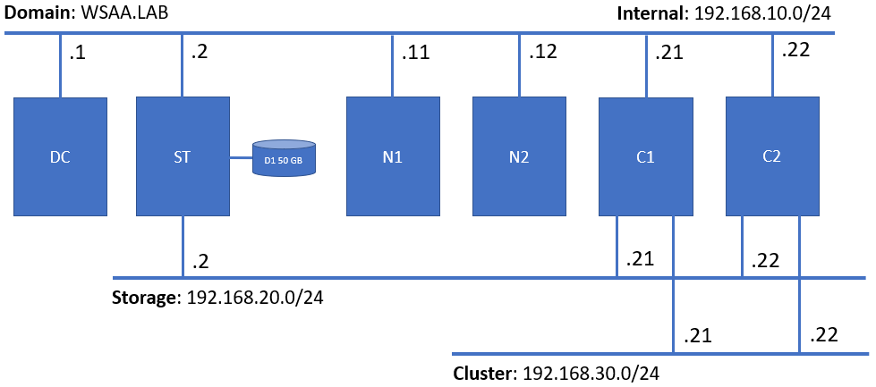

### Proof

The result of your work will be checked in an automated fashion, so please be sure to follow **strictly** the stated names, paths, etc., otherwise you may not get points for some of tasks you consider as done

### Tasks checklist

#### Infrastructure [5 pts]

Considering the setup, and the tasks you are expected to fulfill, do some preliminary work:

* (T101 / 3 pts) Install **File Server** role on **C1** and **C2**
* (T102 / 2 pts) Install the following additional features from the **RSAT Tools** node – **NLB** and **Failover Cluster** including any related PowerShell modules on **DC**

#### Storage [13 pts]

Deploy a simple storage solution utilizing storage pools and **iSCSI technologies**:

* (T201 / 3 pts) Create a volume that occupies the entire spare disk (D1), format it with **NTFS** with allocation unit of **64KB** and assign it a drive letter **P**
* (T202 / 6 pts) Convert the **ST** machine to an **iSCSI target server** by installing and configuring the appropriate components
* (T203 / 2 pts) Create a new **dynamically** expanding iSCSI virtual disk **1 GB** in size and store it on drive P
* (T204 / 2 pts) Create a new **dynamically** expanding iSCSI virtual disk **15 GB** in size and store it on drive P

#### Network Load Balancing [12 pts]

Create and configure a two-node **NLB cluster** by completing the following tasks:

* (T301 / 3 pts) Prepare both **N1** and **N2** to become a part of an NLB cluster
* (T302 / 3 pts) Create a two-node **NLB cluster** named **NLB.WSAA.LAB** with IP address **192.168.99.44**
* (T303 / 1 pts) Configure the cluster mode to be **multicast**
* (T304 / 1 pts) Configure the rule for port **80/tcp** and affinity set to **80**
* (T305 / 2 pts) Create a DNS **A** record named **nlb** pointing to the IP address of the NLB cluster
* (T306 / 2 pts) Create a DNS **CNAME** record named **web** pointing to the FQDN of the **nlb** record

#### Failover Cluster [18 pts]

Create and configure **Windows Server Failover Cluster** that meets the following requirements:

* (T401 / 3 pts) Configure the initiator part on both **C1** and **C2** nodes
* (T402 / 4 pts) Initialize, format, and attach (where applicable) storage for quorum and data to both nodes
* (T403 / 2 pts) Install the required **failover cluster** role components
* (T404 / 3 pts) Create the cluster **SOFS.WSAA.LAB** with IP address set to **192.168.99.33**
* (T405 / 2 pts) Ensure that the storage is appropriately recognized and that there is a **cluster shared volume**
* (T406 / 2 pts) Configure a **Scale-Out File Server** cluster role named **SOFSRole**
* (T407 / 2 pts) Create a share named **SOFSShare** for the **SOFSRole**

#### Desired State Configuration [12 pts]

Create a configuration script using the **PowerShell DSC** techniques that meet the following requirements:

* (T501 / 1 pts) The script should be named **Exam.ps1** and must be stored in **C:\DSC** on the domain controller
* (T502 / 2 pts) Creates a **share** named **Exam** on the **domain controller** and pointing to folder **C:\Exam**
* (T503 / 2 pts) Creates **two** **index.html** files, **personalized** for every node of the NLB cluster, and **store them on the share**
* (T504 / 2 pts) Installs **IIS** on the two NLB nodes
* (T505 / 2 pts) Distributes **index.html** files from the share to the root folder of the default site on each node
* (T506 / 3 pts) Executes **successfully**